Precision Viticulture Report
Sorbara, Modena, Italy
Sorbara, Modena, Italy · EPSG:32632 · 3-year lookback 2024–2026 · generated 2026-07-15

Recommended interventions
Actions suggested by this study, most urgent first. The satellite tells you where and how much — confirm on the ground before intervening.
- Frost protection in cold-air pockets. Cold air pools in: Block 10. Mitigations: position wind machines or heaters in the hollows; use over-vine sprinkler frost protection where water is available; delay or double-prune to push budbreak past the frost window; avoid early-budding varieties/rootstock there; and keep a firm, moist, mown surface on frost nights (bare damp soil re-radiates more stored heat than a tall cover crop).
- Rein in over-vigorous canopy. Excess vigour/chlorophyll in: Block 8. Reduce N inputs, sow or retain a competitive cover crop, and use shoot-thinning/leaf removal; consider a green harvest to rebalance yield and ripening.
- Disease pressure in still, damp hollows. Cold, still hollows (Block 10) also trap humidity, raising downy/powdery mildew pressure. Prioritise canopy airflow (thinning) and tighten spray timing there.

Terroir & terrain
Elevation, slope, sun exposure (heat-load) and topographic position — the static backbone of terroir. Warm SW-facing slopes ripen earliest; hollows are cooler, damper and frost-prone.
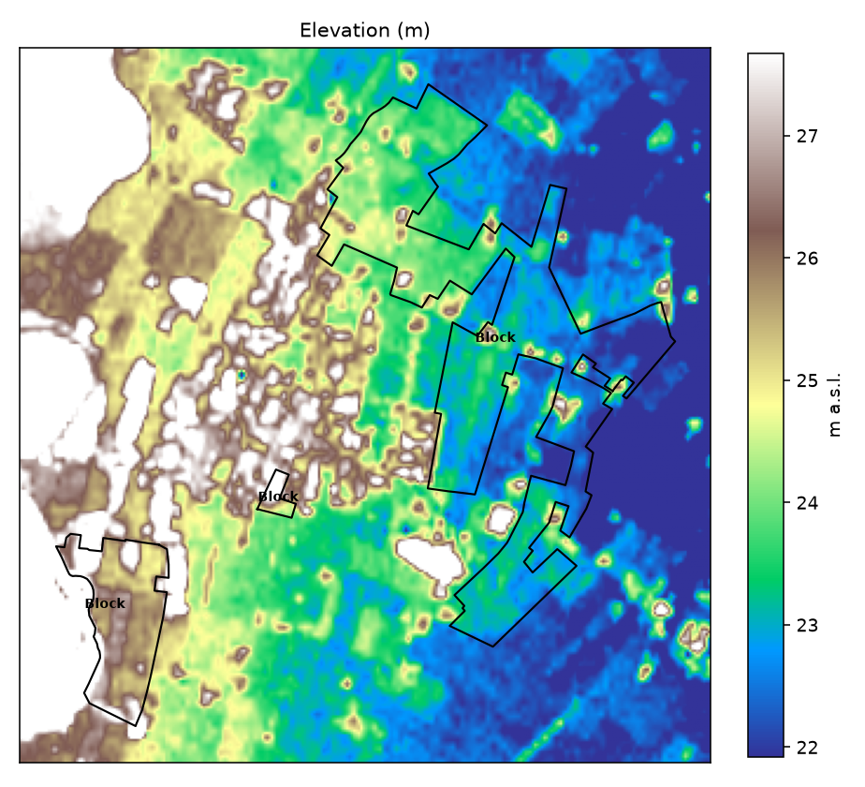
Elevation (m)
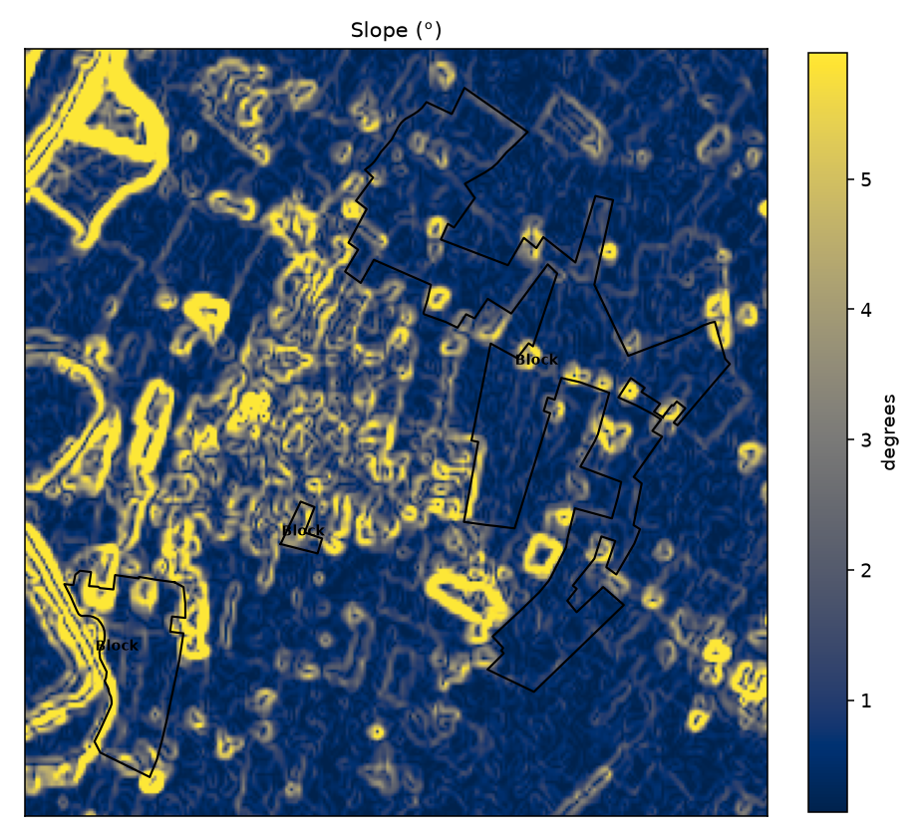
Slope (°)
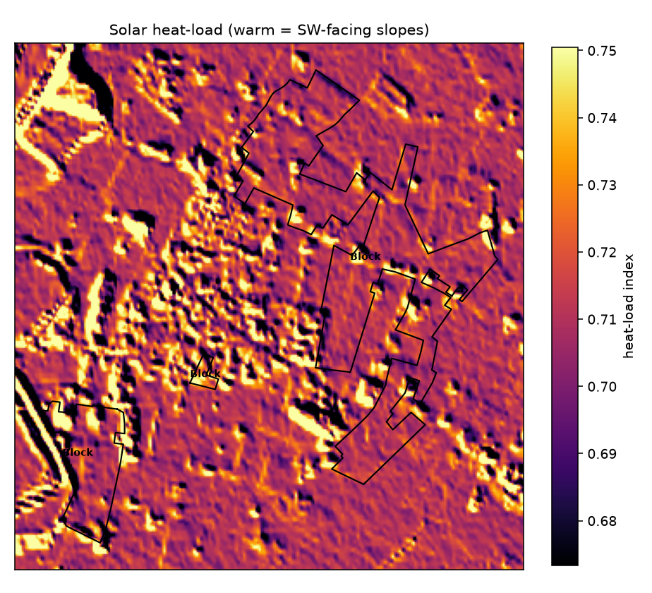
Solar heat-load (warm = SW-facing slopes)
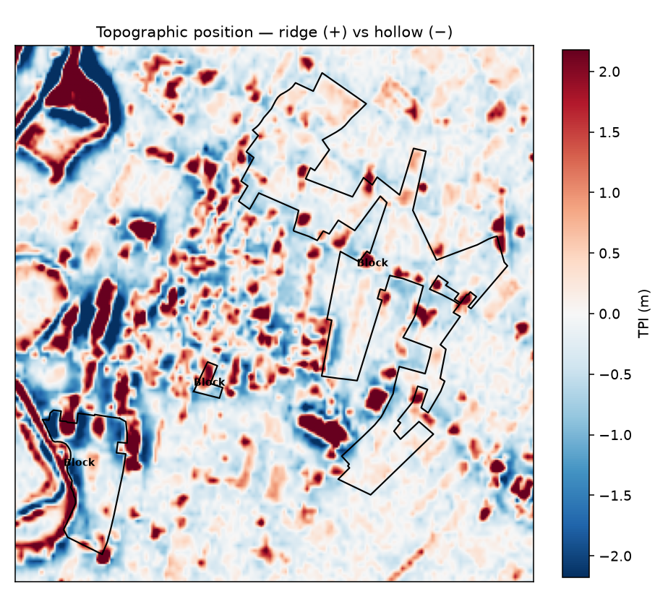
Topographic position — ridge (+) vs hollow (−)

Frost risk
Where cold air pools on radiative-frost nights, from terrain. A daytime satellite can't see the frost night itself, but topography is its dominant control, so this reliably ranks the at-risk blocks.
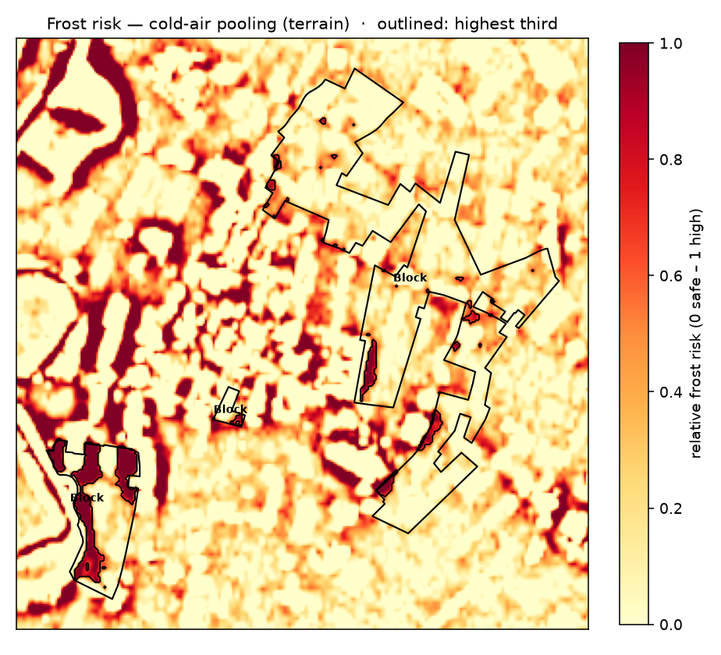
Frost risk (terrain)

Vine vigour & management zones
Multi-year canopy vigour (NDRE) and the management zones clustered from it — the stable strong/weak pattern within each block.
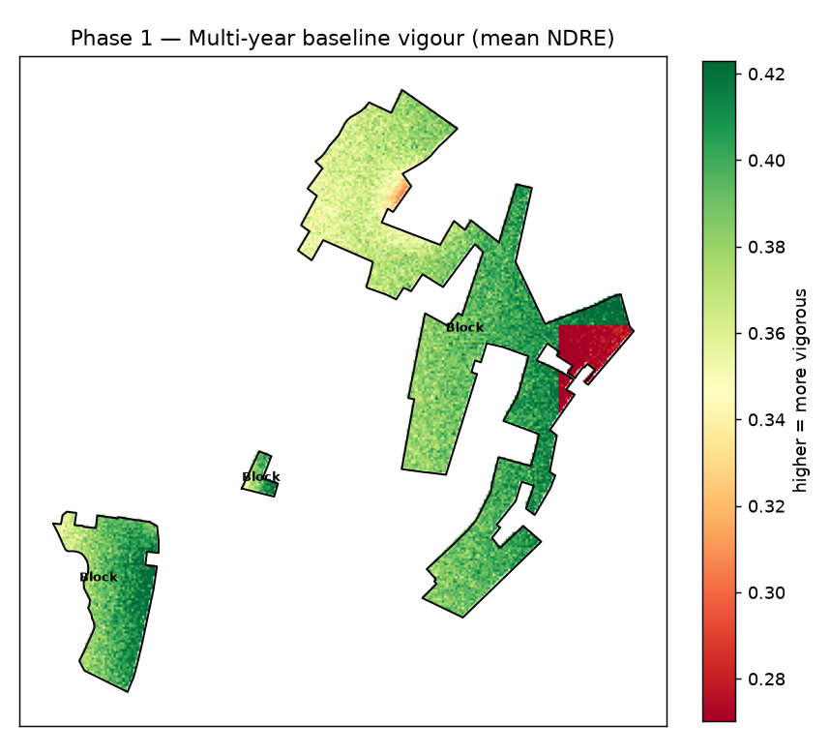
Baseline vigour
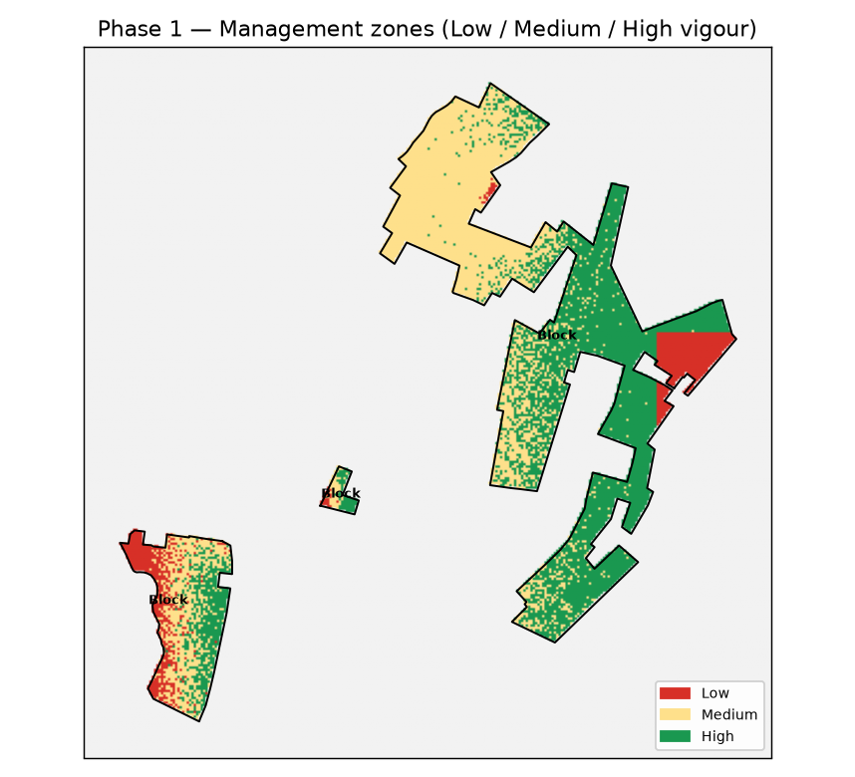
Management zones

Canopy nitrogen / chlorophyll
Red-edge chlorophyll index (CIre) as a proxy for canopy nitrogen status. Read alongside water: at 10 m, water stress can mimic nitrogen deficiency.
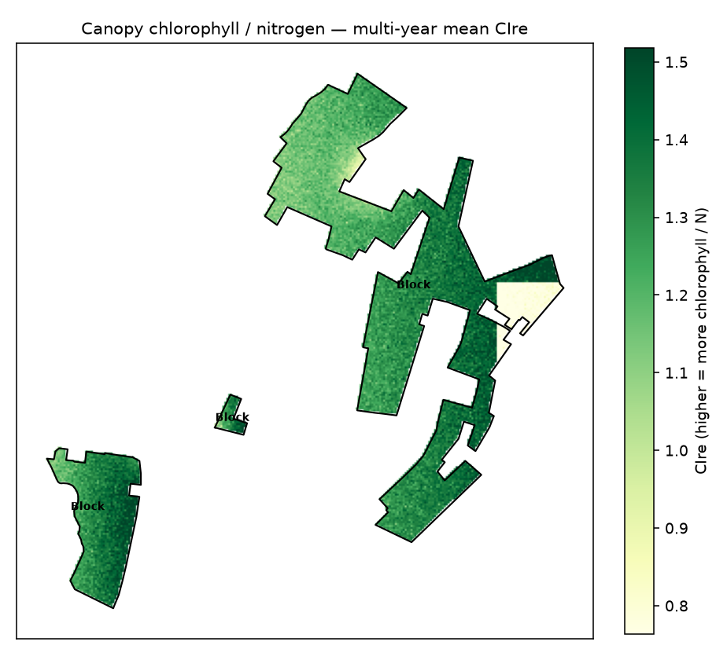
Chlorophyll / nitrogen (CIre)
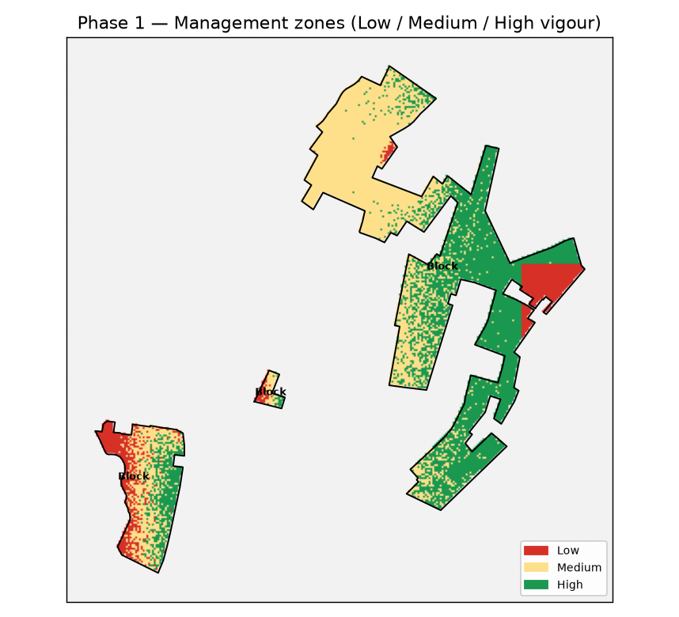
Nitrogen management zones

Seasonal profiles
Every season overlaid by day-of-year (vigour, moisture, temperature) — the operational view for spotting a year peeling away from its own history.
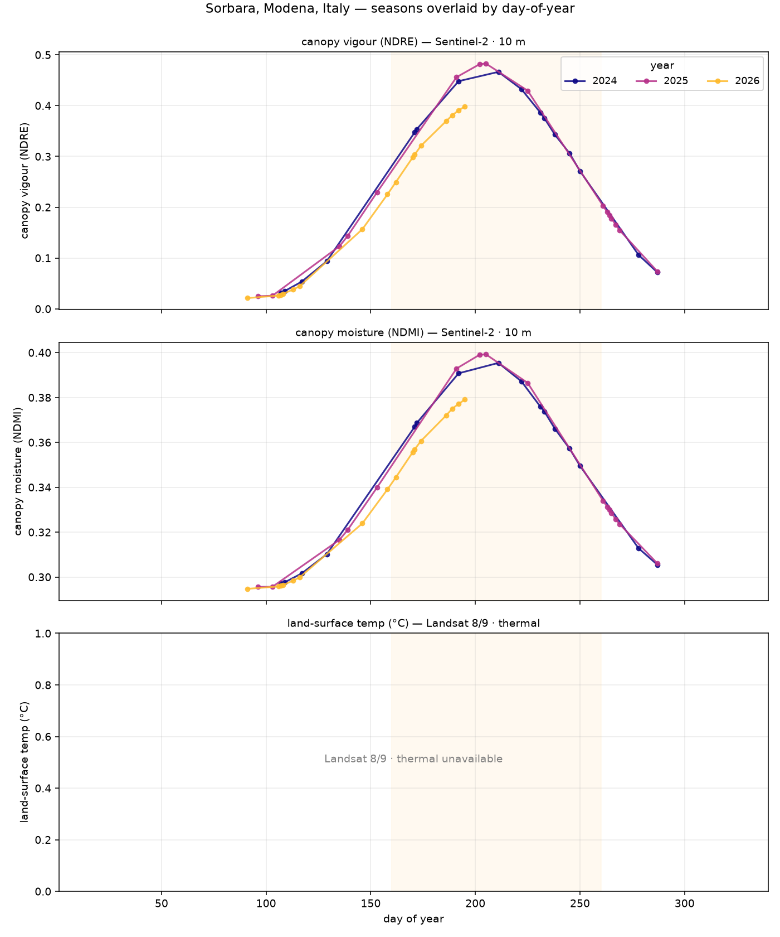
Seasonal overlay (all years)

Data & honest limits
Free satellite sources: Sentinel-2 (10 m optical), Landsat 8/9 (thermal), Sentinel-1 (radar), Copernicus GLO-30 (terrain). Vineyard outlines from the client selection / OpenStreetMap. All maps are georeferenced GeoTIFFs (in the report CRS).
At 10–30 m each pixel blends vine canopy with inter-row ground, so results are relative patterns and change over time, not absolute values or single-vine truth. Frost risk is a terrain proxy; evapotranspiration is a relative fraction (absolute mm needs on-site weather). This layer informs the grower's decisions; it does not replace walking the rows.
Analyses skipped this run: water_stress (produced no output (insufficient clear scenes)); evapotranspiration (produced no output (insufficient clear scenes)); sar_structure (produced no output (insufficient clear scenes))

